**Creating Microservices for account and loan**

**AccountApplication**

package com.cognizant.account;

import org.springframework.boot.SpringApplication;

import org.springframework.boot.autoconfigure.SpringBootApplication;

@SpringBootApplication

public class AccountApplication {

public static void main(String[] args) {

SpringApplication.run(AccountApplication.class, args);

}

}

**AccountController**

package com.cognizant.account;

import java.util.HashMap;

import java.util.Map;

import org.springframework.web.bind.annotation.GetMapping;

import org.springframework.web.bind.annotation.PathVariable;

import org.springframework.web.bind.annotation.RequestMapping;

import org.springframework.web.bind.annotation.RestController;

@RestController

@RequestMapping("/accounts")

public class AccountController {

@GetMapping("/{number}")

public Map<String, Object> getAccount(@PathVariable String number) {

Map<String, Object> response = new HashMap<>();

response.put("number", number);

response.put("type", "savings");

response.put("balance", 234343);

return response;

}

}

**Output:**

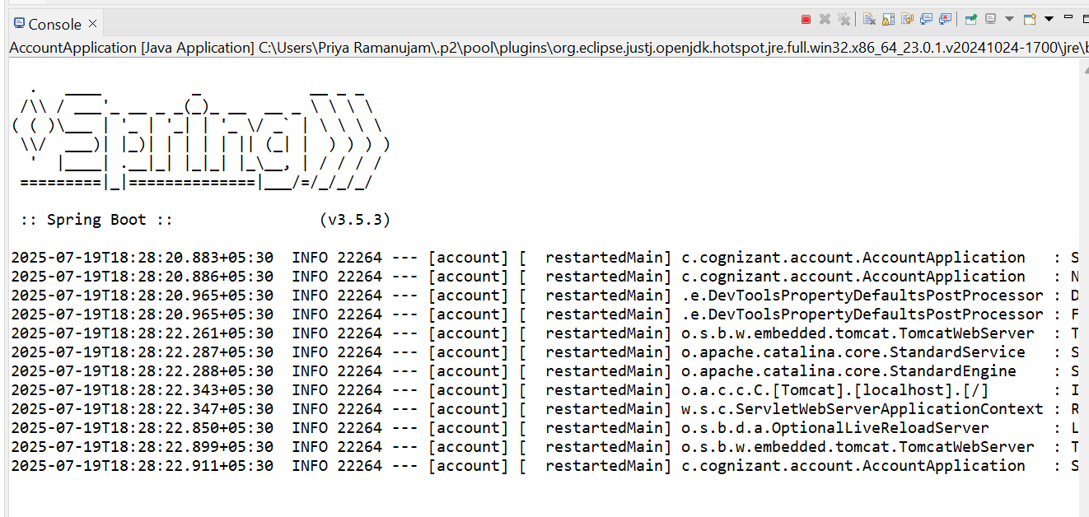

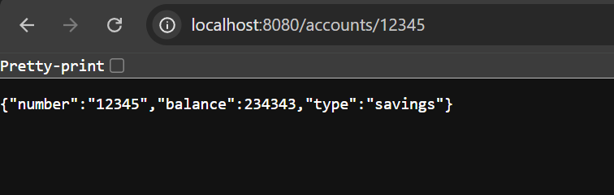

**Create Eureka Discovery Server and register microservices**

**EurekaDiscoveryServerApplication**

package com.cognizant.eureka_discovery_server;

import org.springframework.boot.SpringApplication;

import org.springframework.boot.autoconfigure.SpringBootApplication;

@SpringBootApplication

public class EurekaDiscoveryServerApplication {

public static void main(String[] args) {

SpringApplication.run(EurekaDiscoveryServerApplication.class, args);

}

}

**AccountApplication**

package com.cognizant.account;

import org.springframework.boot.SpringApplication;

import org.springframework.boot.autoconfigure.SpringBootApplication;

import org.springframework.cloud.client.discovery.EnableDiscoveryClient;

@SpringBootApplication

@EnableDiscoveryClient

public class AccountApplication {

public static void main(String[] args) {

SpringApplication.*run*(AccountApplication.class, args);

}

}

**AccountController**

package com.cognizant.account.controller;

import org.springframework.web.bind.annotation.GetMapping;

import org.springframework.web.bind.annotation.PathVariable;

import org.springframework.web.bind.annotation.RestController;

import java.util.HashMap;

import java.util.Map;

@RestController

public class AccountController {

@GetMapping("/accounts/{number}")

public Map<String, Object> getAccountDetails(@PathVariable String number) {

Map<String, Object> account = new HashMap<>();

account.put("number", number);

account.put("type", "savings");

account.put("balance", 234343);

return account;

}

}

**LoanApplication**

package com.cognizant.loan;

import org.springframework.boot.SpringApplication;

import org.springframework.boot.autoconfigure.SpringBootApplication;

import org.springframework.cloud.client.discovery.EnableDiscoveryClient;

@SpringBootApplication

@EnableDiscoveryClient

public class LoanApplication {

public static void main(String[] args) {

SpringApplication.*run*(LoanApplication.class, args);

}

}

**LoanController**

package com.cognizant.loan.controller;

import org.springframework.web.bind.annotation.GetMapping;

import org.springframework.web.bind.annotation.PathVariable;

import org.springframework.web.bind.annotation.RestController;

import java.util.HashMap;

import java.util.Map;

@RestController

public class LoanController {

@GetMapping("/loans/{number}")

public Map<String, Object> getLoanDetails(@PathVariable String number) {

Map<String, Object> loan = new HashMap<>();

loan.put("number", number);

loan.put("type", "car");

loan.put("loan", 400000);

loan.put("emi", 3258);

loan.put("tenure", 18);

return loan;

}

}

**application.properties**

spring.application.name=eureka-discovery-server

spring.application.name=account-service

server.port=8080

spring.application.name=loan-service

server.port=8081

**pom.xml**

<?xml version="1.0" encoding="UTF-8"?>

<project xmlns="http://maven.apache.org/POM/4.0.0" xmlns:xsi="http://www.w3.org/2001/XMLSchema-instance"

xsi:schemaLocation="http://maven.apache.org/POM/4.0.0 https://maven.apache.org/xsd/maven-4.0.0.xsd">

<modelVersion>4.0.0</modelVersion>

<parent>

<groupId>org.springframework.boot</groupId>

<artifactId>spring-boot-starter-parent</artifactId>

<version>3.5.3</version>

<relativePath/> <!-- lookup parent from repository -->

</parent>

<groupId>com.cognizant</groupId>

<artifactId>eureka-discovery-server</artifactId>

<version>0.0.1-SNAPSHOT</version>

<name>eureka-discovery-server</name>

<description>Demo project for Spring Boot</description>

<url/>

<licenses>

<license/>

</licenses>

<developers>

<developer/>

</developers>

<scm>

<connection/>

<developerConnection/>

<tag/>

<url/>

</scm>

<properties>

<java.version>17</java.version>

<spring-cloud.version>2025.0.0</spring-cloud.version>

</properties>

<dependencies>

<dependency>

<groupId>org.springframework.cloud</groupId>

<artifactId>spring-cloud-starter-netflix-eureka-client</artifactId>

</dependency>

<dependency>

<groupId>org.springframework.cloud</groupId>

<artifactId>spring-cloud-starter-netflix-eureka-server</artifactId>

</dependency>

<dependency>

<groupId>org.springframework.boot</groupId>

<artifactId>spring-boot-starter-test</artifactId>

<scope>test</scope>

</dependency>

</dependencies>

<dependencyManagement>

<dependencies>

<dependency>

<groupId>org.springframework.cloud</groupId>

<artifactId>spring-cloud-dependencies</artifactId>

<version>${spring-cloud.version}</version>

<type>pom</type>

<scope>import</scope>

</dependency>

</dependencies>

</dependencyManagement>

<build>

<plugins>

<plugin>

<groupId>org.springframework.boot</groupId>

<artifactId>spring-boot-maven-plugin</artifactId>

</plugin>

</plugins>

</build>

</project>

**Output:**

